1. **INTRODUCTION**
   1. **Overview**

E-commerce is fast gaining ground as an accepted and used business and used business paradigm. It is reasonable to say that the process of shopping on the web is becoming commonplace.

The project is about a e-commerce shoe stores. In this shoe store the users can buy shoes and sandlas and similar products. This shoe store operate with set prices, giving customers a great selection of products at affordable prices.

Through this E-commerce shoe store, a business can process orders, accept payments,manage shipping and logistics, and provide customer service. It deals with monitoring the information and transaction of delivery.

Our project aims at business process automation , i.e. we have tried to computerize various processes of online store.

* 1. **Purpose**

The purpose of the project is to build an application program to reduce the manual work for managing the shoes, customers, cash, payment. It tracks all the details about the payment,delivery,bills.

The main purpose of our shoe store is to make shoe shopping easy and efficient. The purpose of this project is to develop a general purpose e-commerce store where any kind of product can be bought from the comfort of home through the internet.

1. **LITERATURE SURVEY**

* 1. **Existing problem**

* Cyber & Data Security
* Online Identity Verification
* Attracting the Perfect Customer
* Converting Shoppers into Paying Customers
* CustomerLoyalty
* Product Return & Refund Policies
* Price & Shipping
* Customer support
* Data privacy

**2.1 Proposed solutions**

**1. Cyber & Data Security**

Be vigilant and always back up your data. Post that, you can install security plugins onto your website to prevent it from getting hacked. There are several plugins out there, pick one that works best for your eCommerce website.

**2. Online Identity Verification**

There are different ways to incorporate online identity verification. Some examples include biometrics, AI, single sign on, one time password, two-factor authentication and so on.

**3. Attracting the Perfect Customer**

Partner with companies that help you target your customers. Digital marketing is preferred over traditional marketing because they can target your ideal customer. While this might not happen overnight, with A/B testing, fine tuning and analysis – your products could be showing up to potential customers on different social media platforms.

**4. Customer Experience**

There are [several ways to improve the user experience](https://vue.ai/blog/ai-in-retail/ecommerce-user-experience-best-practices/). The most important would be to have a clean and simple website so that shoppers can navigate through easily. The next point would be to have clear CTAs (call to action) so that the shopper knows exactly what to do. Here is a post that shows you 10 ways to improve user experience.

**5. Customer Loyalty**

These are a few different methods that can be used to retain customers. The first would be to have excellent customer service – a customer is happy to have purchased a great product, but they are ecstatic when the customer service is on point. The next step is to keep in touch with the customer via a method that they like – be it an email, SMS or blog posts – be sure to find out what works best for your customer. The last point would be to let them know about new products, sales promotions and special coupon codes for being such loyal customers.

**6. Converting Shoppers into Paying Customers**

The first and foremost would be to understand why your shoppers aren’t converting – are you targeting the right audience? Is your mobile website working seamlessly? Do your online platforms face technical challenges all the time? Does your customer base trust you? Do you [personalize](https://vue.ai/solutions/personalization-engine/) your website for your customers? Always think from a shopper’s perspective and see if you are doing everything possible to make them paying customers.

**7. Price & Shipping**

While all eCommerce sites cannot completely get rid of shipping costs, always look to find options that work for your customer base. Would a subscription reduce the cost of shipping? Would a certain time of the month give them lower shipping costs?

**8. Product Return & Refund Policies**

Customer satisfaction is the most important factor for any retailer. Therefore having a flexible return and refund policy not only helps with customer satisfaction with it also helps with customers making purchases without being nervous.

**9. Data Privacy**

Collect Zero-party data, where your customers will intentionally and voluntarily share their data with your brand as opposed to collecting third-party data, which is what customers these days are extremely cautious about

**10. Customer Support**

The solution to this **eCommerce challenges** is fairly simple – eCommerce companies should utilize a combination of technology and human assistance to deal with customer support by tagging specific issues that require human assistance and distinguishing the queries that can be handled by a chatbot.

1. **THEORETICAL ANALYSIS** 
   1. **Block diagram**

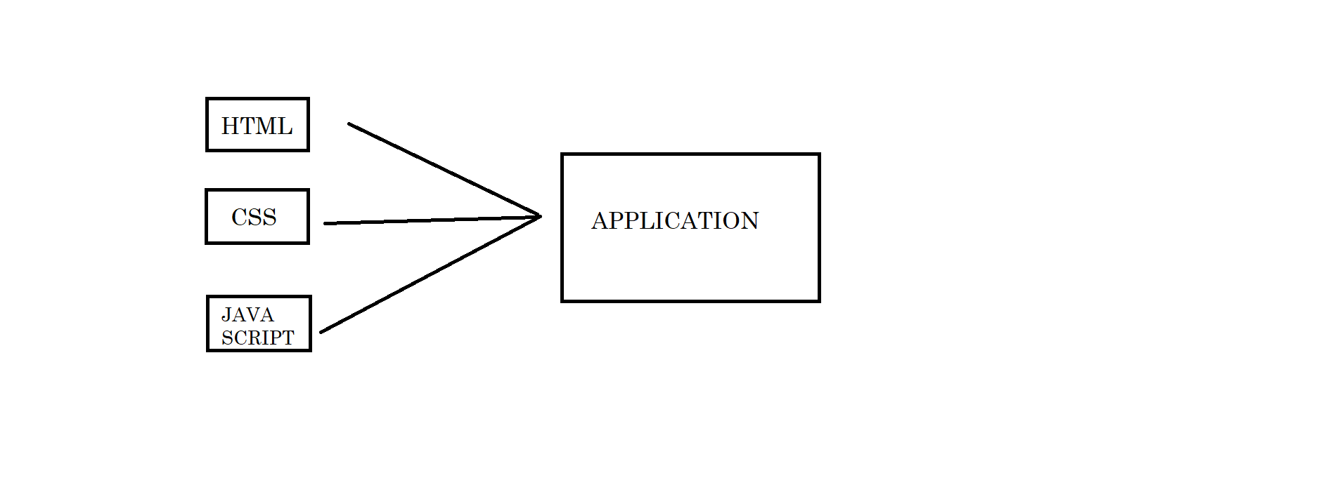

* 1. **Hardware / Software designing**

**Software Requirement:**

Along with the hardware, used in the system it requires software to make a System as well as to run a system with the computer hardware.

Collection of Different type of hardware into a specific type can form a computer but it Cannot execute different process on its own.

For efficient and proper Working of any system software must be installed .This software may be in The form of operation system or application software.To make the system One also needs to use software.

**SOFTWARES USED FOR DESIGNIG :**

Software : Visual studio code

Operating system : Microsoft windows xp/10/11

Programming : html,css,javascript

Browser compability : chrome , edge

**Hardware Requirement:**

This phase of the software development process deals with a brief study of Different hardware used in the computerized system.

This is a list of Hardware materials used during the making and also during the use of the proposed system.

As the new system to be made into computerized Functional system, requirement of a computer is must.

All the hardware needed here are generally the basic configuration of atypical office Computer.

**The following Hardware are required:**

* Pentium® IV processor or other compatible
* Intel® chipset Motherboard
* 1 GB RAM
* 2 -4 GB Hard-Disk
* Moniter
* Keyboard
* Mouse

1. **RESULT**

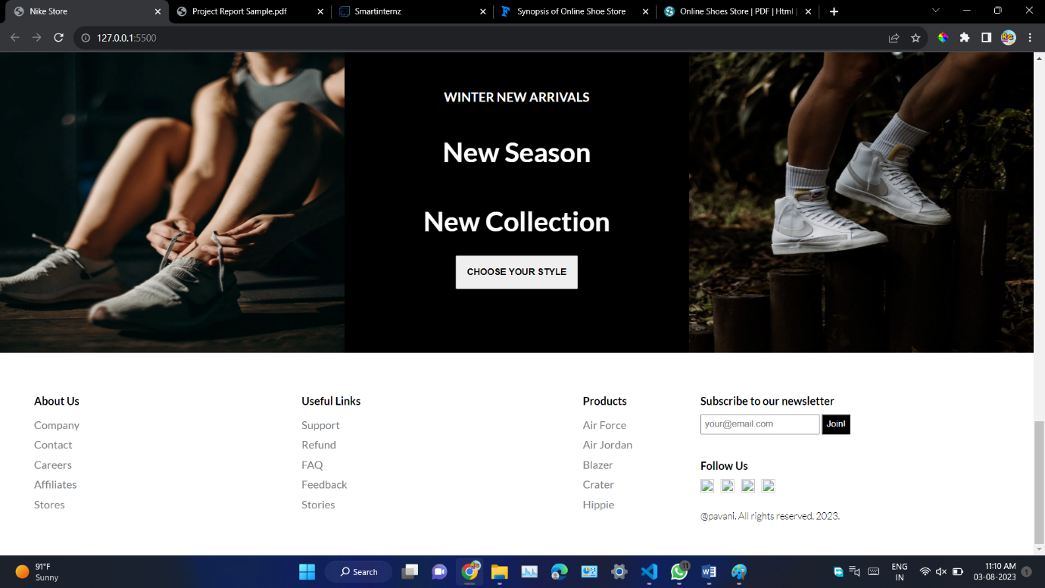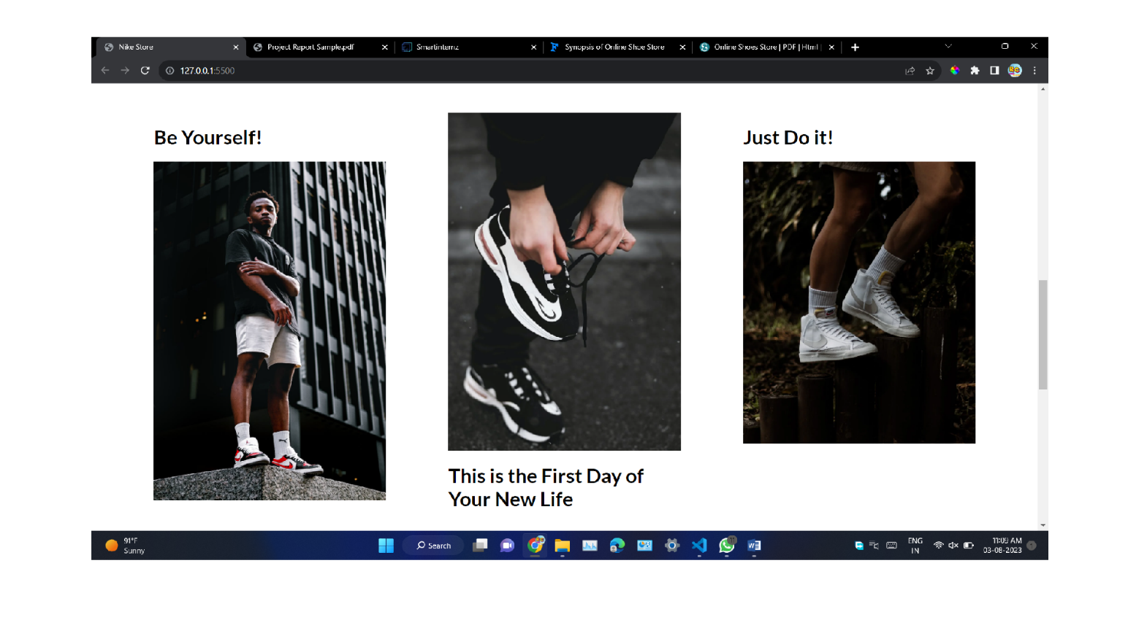

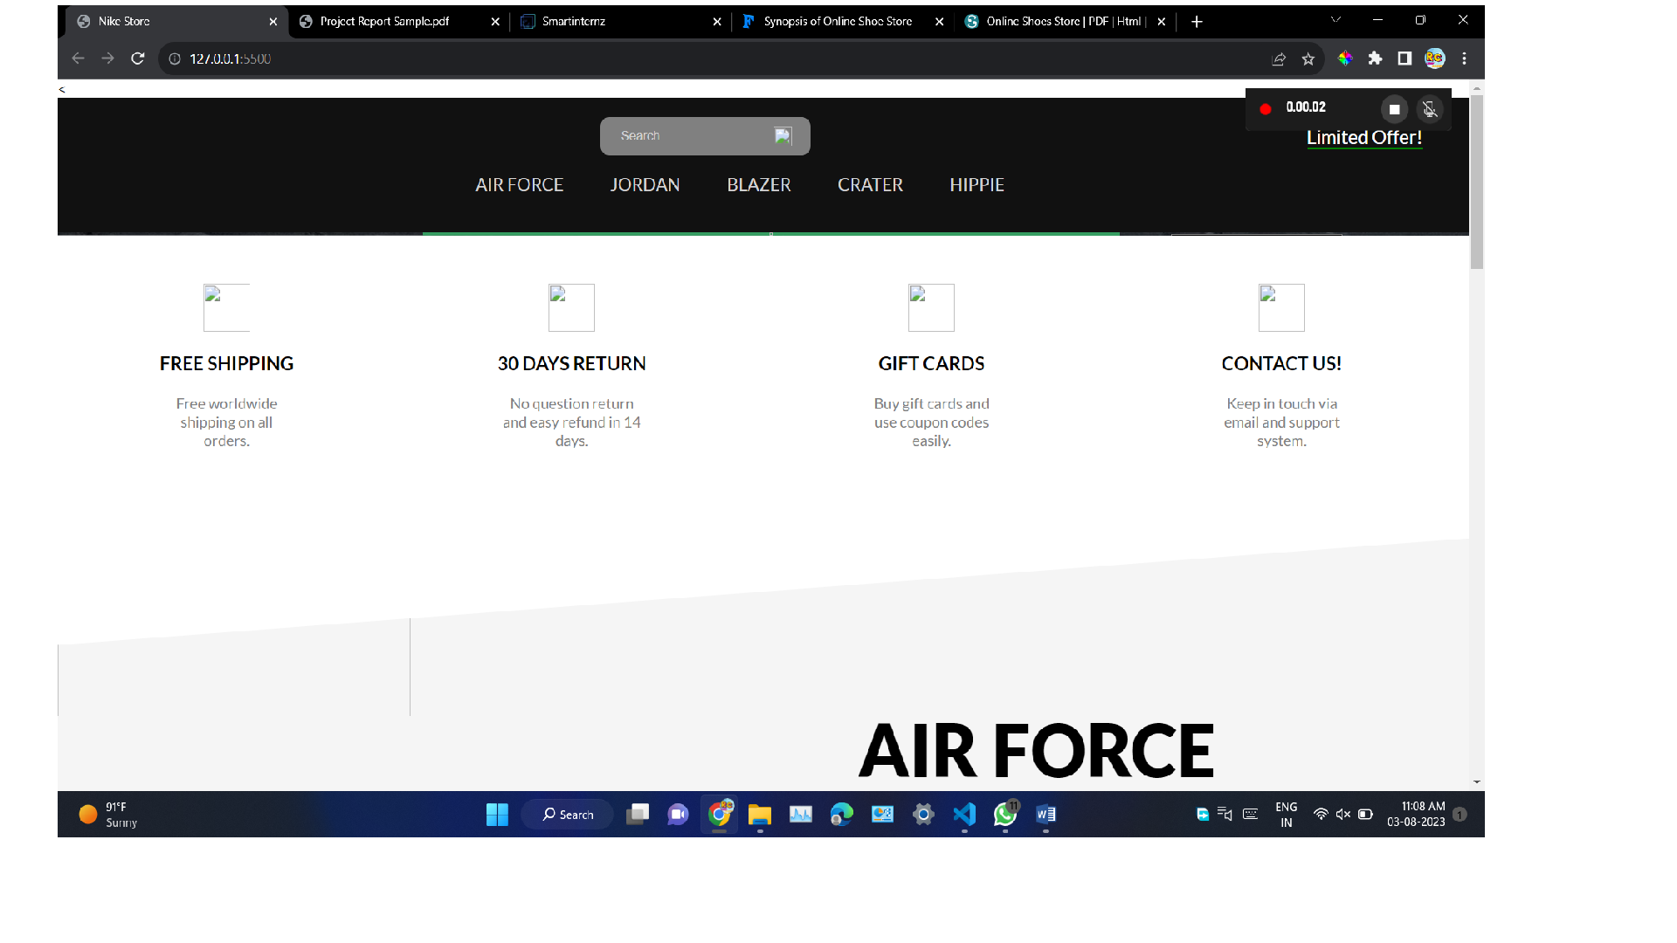

1. **Advantages of e-Commerce shoe store**

There are a number of prominent and not-so-obvious advantages for doing business on an online platform. Understanding exactly how e-Commerce works can help individuals leverage them to their and their businesses advantage:

1. **A Larger Market:** E-Commerce allows individuals to reach customers all across the country and all around the world. E-Commerce gives business owners the platform to reach people from the comfort of their homes. The customers can make any purchase anytime and anywhere, and significantly more individuals are getting used to shopping on their mobile devices.
2. **Customer Insights Via Tracking And Analytics:** Whether the businesses are sending the visitors to their eCommerce website via PPC, SEO, ads, or a good old postcard, there is a way of tracking the traffic and the consumers’ entire user journey for getting insights into the keywords, marketing message, user experience, pricing strategy, and many more.
3. **Fast Response To The Consumer Trends And The Market Demands:** Especially for the business people who do “drop ship,” the logistics, when streamlined, allow these businesses to respond to the market and the trends of eCommerce and demands of the consumers in a lively manner. Business people can also create deals and promotions on the fly for attracting customers and generate more sales.
4. **Lower Cost:** With the advancement of the eCommerce platforms, it has become very affordable and easy to set up and run an eCommerce business with a lower overhead. Business people no longer need to spend a big budget on TV ads or billboards, nor think about personnel and real estate expenses.
5. **More Opportunities For “Selling.”:** Business people can only offer a limited amount of information about a product in a physical store. Besides that, eCommerce websites give them the space to include more information like reviews, demo videos, and customer testimonials for helping increased conversion.
6. **Personalised Messaging:** E-Commerce platforms give people in business the opportunity to provide personalised content and product recommendations for registering customers. These targeted communications can help in increasing conversion by showing the most relevant content to the visitor.

**Disadvantages of e-Commerce shoe store**

Running a business that is e-commerce is not always rainbows and unicorns. There are unique challenges to this business model — learning about them will help business people navigate the choppy waters and avoid common pitfalls.

1. **Lack of Personal Touch:** Some customers appreciate the personal touch they offer when visiting a physical store by interacting with the sales associates. Such personal touch is especially essential for businesses that sell high-end products as customers will want to buy the products and have an excellent experience during the process.
2. **Lack of Tactile Experience:** No matter how good a video is made, customers still can’t feel and touch a product. Not to mention, it’s never an easy task to deliver a brand experience that could often be including the sense of touch, taste, smell, and sound via the two-dimensionality of any screen.
3. **Product and Price Comparison:** With online shopping, customers can compare several products and find the least price. This forces many businesses to compete on price and reduce their profit margin, reducing the quality of products.
4. **Need for Access to the Internet:** This is obvious, but don’t forget that the customers do need access to the Internet before purchasing from any business! As many eCommerce platforms have the features and functionalities which require a high-speed Internet connection for an optimal consumer experience, there’s a chance that companies are excluding visitors who have slow internet connections.
5. **Credit Card Fraud:** Credit card frauds are a natural and growing problem for online businesses. It can lead to many chargebacks, which result in the loss of penalties, revenue, and a bad reputation.
6. **IT Security Issues:** More and more organisations and businesses have fallen prey to malicious hackers who have stolen information of the customers from their databases. This could have financial and legal implications, but it also reduces the company’s trust.

**6. APPLICATIONS**

* Widely used by so many shoe companies to attract the customers.
* The promotion of the new products and offers is easy.
* Easy to access from any where with internet.
* Easily build the big network.
* Customization of the product is easy.
* Easy to order and track the product.
* Publicity of the brand will be easier.

**7. CONCLUSION**

“Online Shoes store” project is aimed at developing a web application that

depicts online shopping for any product.This application advertises some of the apparels for every product. To purchase product customer has to create an account. Those who does not havean account, Once the customer has created account, not only he can view the product.

Admin:

Admin adds the new product and stores in the database which can beretrieved and used whenever needed and all the validation are performedduring the entry of the data. Thus it ensures that the user cannot enter anywrong data which would cause problem later.

User:

This application allows the user to access all theproduct available. To purchase product, customer must create an account in this website.It alsoincludes the concept to enter transaction reports and to maintain customerrecords very easily.

**8. FUTURESCOPE**

In a nutshell it can be summarized that the future scope of the project circles around maintaining information regarding:

* We can add printer in future.
* We can give more advance software for online shoes including more facilities
* We will host the platform on online servers to make it accessible worldwide
* Integrate multiple load balancers to distribute structure to reduce the overload of the database queries
* Create the master and slave database structure to reduce the overload of the database queries
* Implement the backup mechanism for taking backup of codebase and database on regular basis on different servers